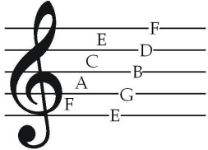HARROW BEIJING MUSIC DEPARTMENT

PUPIL INTEREST SURVEY

We want you to have the best possible learning experience in Music at Harrow Beijing. Please help us by answering the following questions:

What is your English name? …………………………………………………

Which class are you in? ……………………

Do you like music? …………………

Do you play any musical instrument/s? …………

What instrument/s can you play? …………………………………………………………………………

For how long have you been playing this/these instruments? ……………………………………… ………………………………………

Have you performed solo in any concerts? ……………………………

Have you played in an orchestra, or small ensemble? ………………………

Do you like singing? ……………

Would you say that you are a good singer? ……………………

Do you like singing in a choir? ……………………

What is your favourite style of music? Classic, Jazz, Pop etc. …………………………

Do you have a favourite composer, if so, who? …………………………………………………

Can you read music? ………………………………………………………………………………

Have you ever tried composing music? ……………………

What do you want to learn in Music this year? Please think hard before you answer. …………………………………………………………………………………

………………………………………………………………………………………………………………………

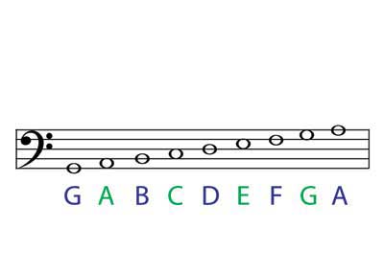THANK YOU FOR COMPLETING THIS SURVEY. Now let’s make MUSIC!