Kaijia Saariaho: Petals for Cello solo and Optional electronics

1. The term ‘Musique Concrete’ applies to ________________________________________________________________________________________________________________________________________________________________________________________________________________________
2. Name 4 Key Music Concrete works by Varese, Henry, Ferrari, Boulez:

___________________________________

___________________________________

___________________________________

___________________________________

1. Music spectrale based on ________________________________________________________________________________________________________________________________________________________________________________________________________________________
2. Why timbre and texture are prioritised in Musique spectrale? _________________________________________________________________________________________________________________________________________________________________________________________________________________________
3. What is a ring modulation? ________________________________________________________________________________________________________________________________________________________________________________________________________________________
4. Describe the relation of timbre and variation of timbre and structure to the relation of tonality and structure in 19th century ________________________________________________________________________________________________________________________________________________________________________________________________________________________________________________________________________________________________
5. Explain why change of timbre over the time is the aim of Musique spectrale________________________________________________________________________________________________________________________________________________________________________________________________________________________________________________________________________________________
6. Listen to Grisey and Murail`s pieces, which orchestral and electronic effects did they use in their works?

9. Make notes (better just copy and memorise word to word) the impact of previous composers such as Debussy, Varese, Messiaen, Ligeti, Berio on the 20th century music.

Listen to their pieces.

Kaijia Saariaho and her music

1. Where Saariaho from and where did she study?

_____________________________________________________________________

1. Describe and list her avantgarde compositional techniques___________________________________________________________________________________________________________________________________________________________________________________________________________________________________________________________________________
2. How does she creates the effects of distance, weightlessness and ethereality?

____________________________________________________________________________________________________________________________________________________________________________________________________________________________________________________________________________________

1. Copy 2 paragraphs of Tom Servise describing her imaginative works:
2. Listen to S`s 5 pieces and find out the common ingredients of her works, to make sure you have enough points for writing an essay:

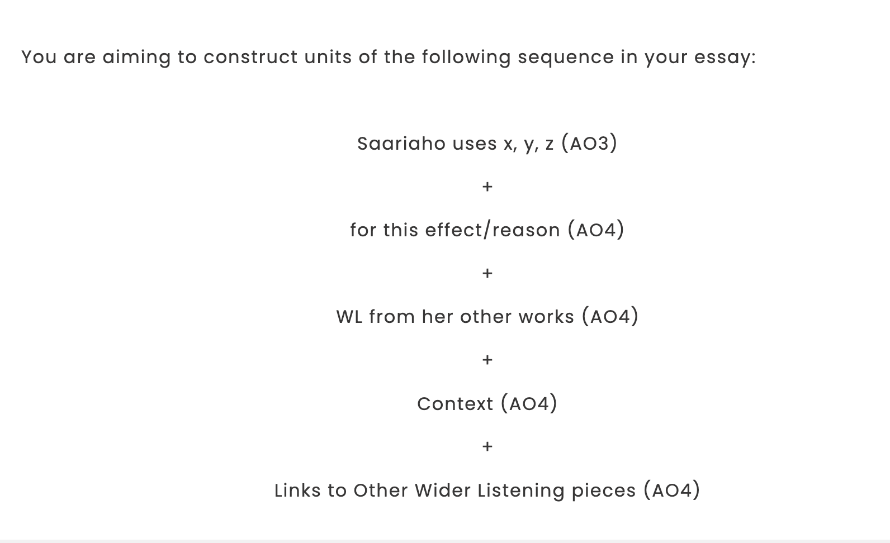

The Background to Petals and its use of Electronics

1. For which instrument it`s written and in which style?
2. Petals meaning, and inspiration
3. How is the responsive relationship between the cello and electronic sounds achieved?
4. Which electronics are used? Do they use a sound engineer?
5. What is Reverberation?
6. Who else the effect of Harmoniser? What is it?
7. Which software is needed for the performance?
8. Explain why composer interchanged the musical elements? For example why rhythm became a texture? Harmony becomes timbre?
9. Make notes of every single explanation of the notation, techniques used, copy and memorise the main features, all these points can be very useful in your essay questions:

* Structure
* Sonority/timbre
* Texture monophonic?