Open and Close positions:

4th and 5th.T-S

3rd T-III

2nd S -D

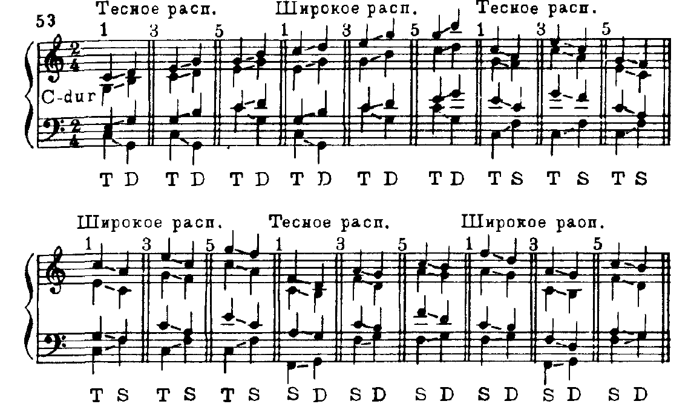

Harmonise this melody using T, S and D chords

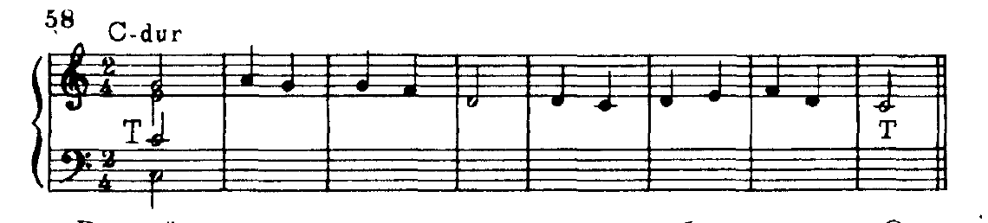

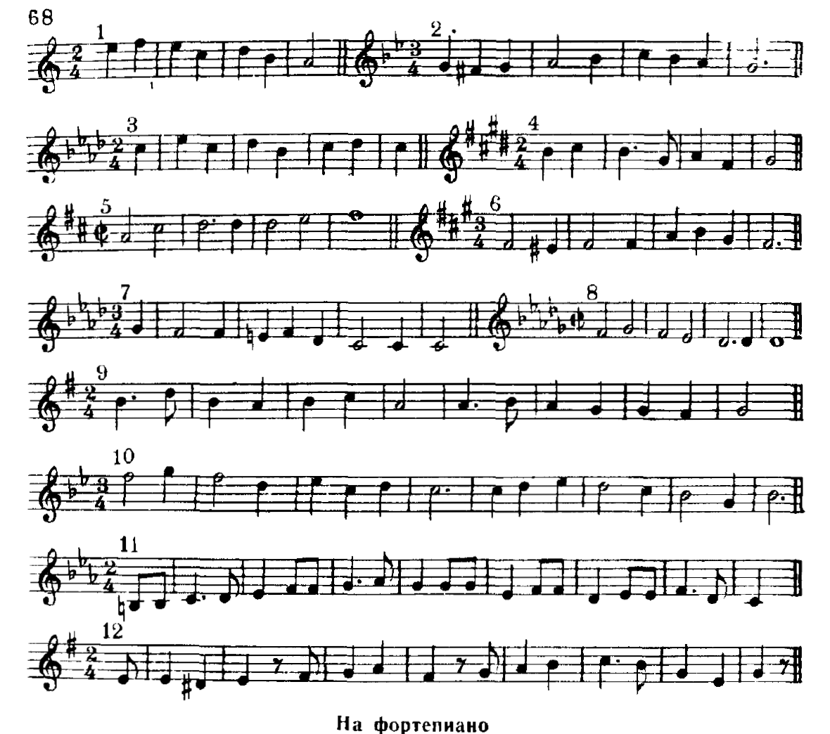

Answer:

